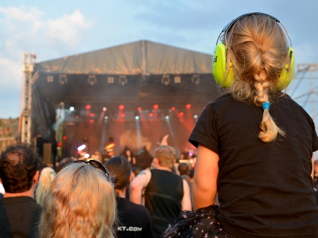**Hearing Protection + Hearing Aid Tips So You Can Have Fun in the Sun!**

Summer months are approaching! This means your patients may be partaking in outdoor concerts, swimming, and spending more time outdoors than usual. It’s important to educate patients on hearing protection devices when they participate in the above activities.

Along with the humidity and perspiration during these scorching months, it’s also crucial to keep up with routine hearing aid maintenance too.

**Noise Exposure**

People of all ages can be affected by noise induced hearing loss (NIHL). Signs of NIHL may not be obvious at first, but they can build over time. According to the CDC, 12.5% of children and adolescents between the ages of 6 and 19, and 17% of adults between the ages of 20 and 69, have permanent hearing loss from repeated exposure to loud noises.

“Make healthy hearing a habit when you are young so that you can avoid NIHL. Exposure to loud sounds can have life-long consequences on your hearing, including making it difficult to communicate with others and to appreciate the sounds of nature and music”- Judith A. Cooper, Ph.D.

**Hearing Protection**

Hearing protection devices offer comprehensive protection against loud noises, safeguarding against noise-induced hearing loss in industrial, recreational, or occupational settings. These devices come in various forms, including earmuffs and custom-made earpieces, providing personalized solutions for optimal comfort and effectiveness. **Noise plugs attenuate excessive noise levels while maintaining clarity for communication and awareness of surroundings. For swimmers and water enthusiasts, swim plugs provide a watertight seal to prevent water from entering the ear canals, reducing the risk of infections and swimmer’s ear.**

**Hearing Aid tips:**

* Schedule an appointment with your audiologist every 6 months for deep cleanings. At Now Hear This®, we use an industrial dryer called the Redux which absorbs moisture from the inside of hearing aids.
* Keep an electric dryer at home and use it regularly.
* Use a toothbrush to brush all the microphones: this will help get rid of debris resulting in hearing aids producing clearer sounds.

**At Now Hear This® we offer custom noise, swim, and sleep plugs!**