**Beyond Clinicians - The Patient Centered Approach**

More and more health-care service delivery systems have matured away from a practitioner focused approach to patient centered care. Unfortunately, in many fields this focus has been slow to change. In 2024, it is well established that audiology patients will receive their best care and be most empowered to seek effective treatment if the provider utilizes not only evidence-based practices such as questionnaires, speech in noise testing, and Real Ear Measurement, **but also take the time to discuss rehabilitation options with patients according to their personal and individual lifestyle needs**.

At Now Hear This®, we pride ourselves in taking the time to not only provide best practice testing and treatment for hearing loss, but also **to build relationships with our patients so we can better understand their day-to-day listening and communication difficulties.**

Meet “**Raleigh’s Best”** (2021, 2022, & 2023) Doctors of Audiology:

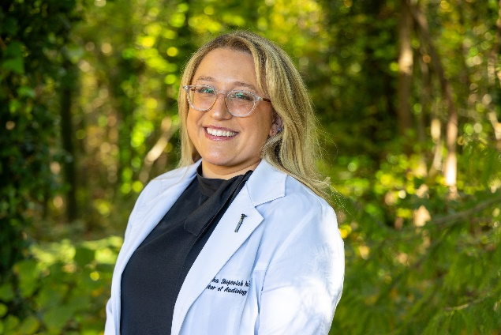

**Dr. Samantha Shopovick, AuD, CCC-A** earned her Bachelor of Science degree in Communication Sciences and Disorders from Auburn University and her clinical Doctorate of Audiology degree from Ohio University. Before working at Now Hear ThisⒸ, Dr. Shopovick worked at an Otolaryngology clinic seeing a diverse caseload that has made her well-trained in all aspects of Audiology.

Her specialties include adult diagnostics, adult hearing aid fittings, and adult cochlear implant programming. She uses the most recent evidence-based practices during her programming appointments with the goal of enabling individuals to maintain communication with their loved ones.

**Dr. Megan Schlater, AuD** earned her bachelor’s degree in early childhood education and was an elementary school teacher for five years before she found an interest in Audiology. She earned her clinical doctorate in Audiology from the Northeast Ohio Au.D Consortium.

Dr. Schlater’s specialties include adult diagnostics, adult hearing aid fittings and reprogramming, assistive listening devices, and Tinnitus management. She uses evidence-based practice including Real Ear Measures and Speech in Noise testing during hearing aid programming appointments to verify hearing aids are functioning optimally.

Do you have patients who struggle to hear, but deserve more time and a quality relationship from their audiology provider? Refer them to Now Hear This® Audiology!

Boisvert I, Clemesha J, Lundmark E, Crome E, Barr C, McMahon CM. Decision-Making in Audiology: Balancing Evidence-Based Practice and Patient-Centered Care. Trends Hear. 2017.

